**NEW ARRIVAL**

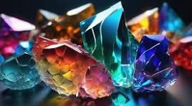

**Name:** Multi Shade Amethyst

**Brand:** Baccarat

**Model#:** 001

**Color:** Multi-Shading

**Price: $2000**